**How we made our sensor**

1. 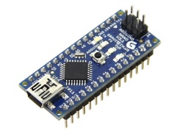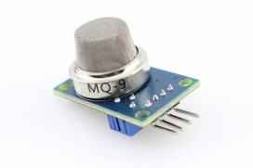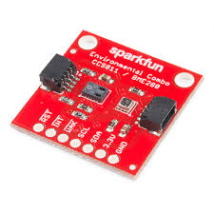Modules used

* Arduino Nano
* 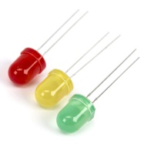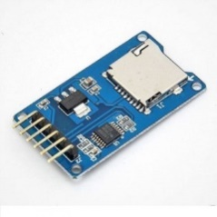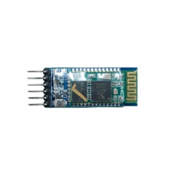Sensor
* MQ-135
* Bluetooth Module
* SD card Module
* Leds

1. Assemble the circuit

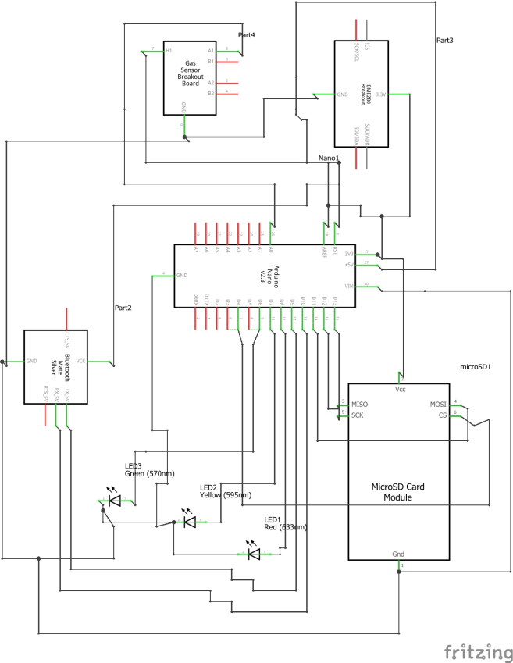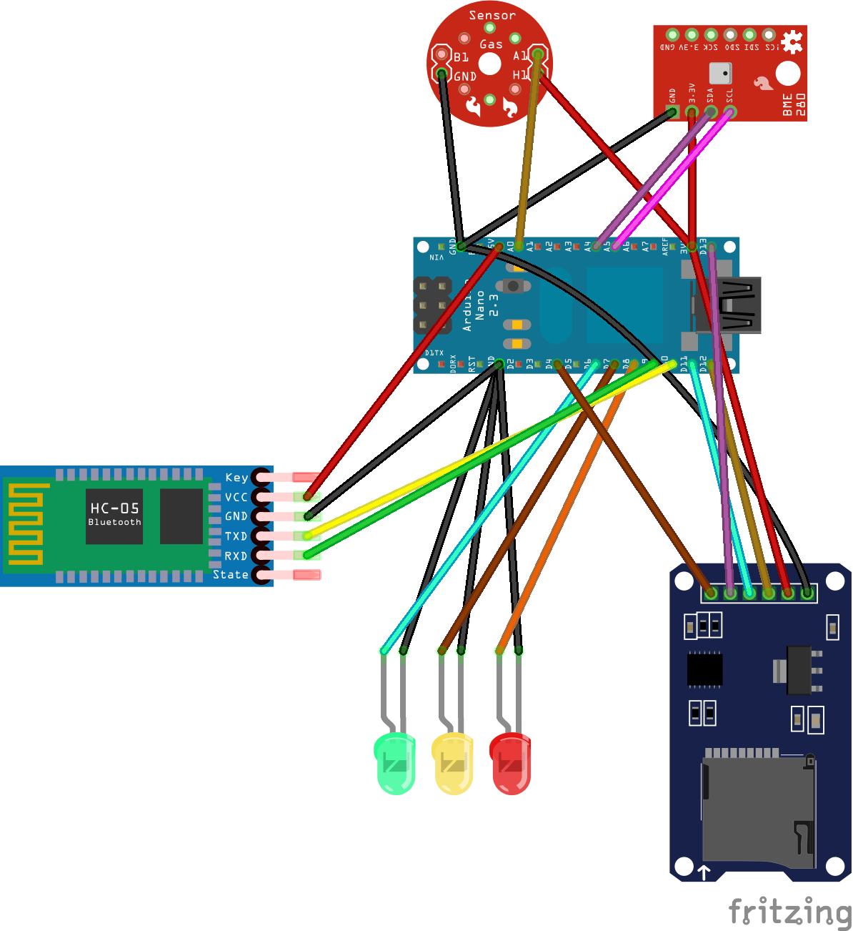

1. Write the code
2. Take measurements

We wanted to detect what the sensor is capable of

Before making an analysis about air pollution, the well-known climate change and how the human can reverse it or slow it down, we have to examine how clean the air in some places is. For example, we went in three different mountain-surrounded areas, where we measured the followings:

Time for testing

We wanted to show how clean the air is in different places far from the city. However, we didn’t take in consideration an important factor: the smoker.

Thus, we can notice what the effect of smoke to the nature is.

Smoking; bad just for you or for everybody?

Those measurements show how dangerous passive smoking is. While I was talking with some friends in a smoking lounge for about 10 minutes on 2 different days, I took data in order to analyse it. Those spikes come from blowing smoke directly into the sensor, as if you were talking pretty close to somebody that just smoked a cigarette.

In normal conditions, the **CO2** level should be around 400 ppm (parts-per-million), the **TVOC** level should be between 300 and 500 ppb and the **gas** level should be around 30.

Are ecological products better?

Those measurements were recorded in our school, precisely on our chemistry laboratory. I was curious if all the substances from the laboratory could affect in any way our sensors and I definitely got some results. The outcome is way higher than I thought it would be. This exposure may harm the chemistry teachers if they spend too much time around those substances. These substances are found in most of non-ecological home products. We take as an example cleaning products. The normal detergents contain lots of chemical compounds that are really harmful for us.

How about our city?

We googled how polutted our city is and all we found was that it is one of the most polluted cities in our country. We didn’t really believe those informations so we went on searching for ourselves. As you can see, the numbers aren’t that bad, considering that the carbon emissons(CO2 level) are about 447 ppm (parts-per-million) and the typical concentrations of occupied indoor spaces with good air flow are between 350 ppm and 1000 ppm . The tvoc level (Total Volatile Organic Compound ) in Iasi is 6.7 ( parts-per-billion), and the “excelent” value confirmed by studies is between 0 ppb and 65 ppb. And the gas level is also into the average gas level ( 20 ppm ).

Walking may be a better solution…

One of the biggest flaws in cities is the carbon emissions from cars. The Environmental Defense Fund (EDF) estimates that on-road vehicles cause one-third of the air pollution that produces smog. So I compared the smoke that came out of an Euro 6 motor car with an older version, the Euro 3 motor car. The results came out pretty engaging:

How much do we pollute the air every moment?

We also wanted to see how polluted a pedestrian zone is, mainly beacause there are a lot of people going back and forth, which makes it very crowded, therefore very polluted . As you can see, the results are still pretty normal.

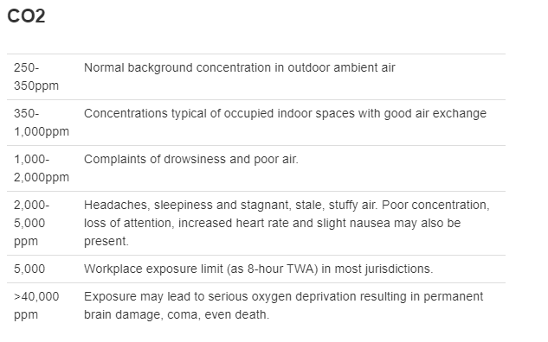

Source: [www.kane.co.uk](http://www.kane.co.uk)

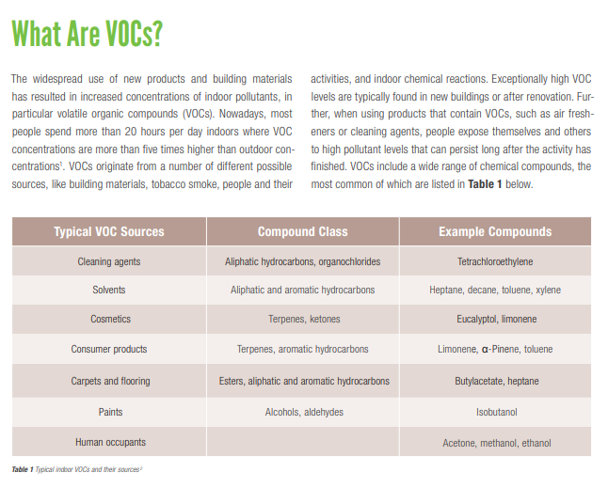

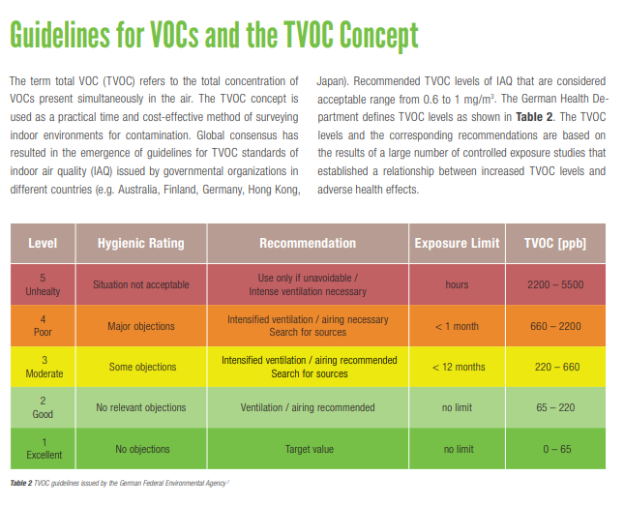

Source: [www.repcomsrl.com](http://www.repcomsrl.com)